PREDICTIVE ANALYTICS
PROJECT REPORT
(Project Semester August–December 2026)

MONSOON AND AIR POLLUTION PREDICTIVE ANALYTICS
Data Science Minor Project
Submitted by
Shashank Kumar
Registration No. 12410350
Programme and Section B.Tech CSE – Section – K3P24FV
Course Code INT234
Under the Guidance of
Dr. Madhu Bala, ID: 31770
Discipline of CSE/IT
Lovely School of Computer Science and Engineering
Lovely Professional University, Phagwara

DECLARATION
I, Shashank Kumar, student of B.Tech CSE – Section – K3P24FV under CSE/IT Discipline at Lovely Professional University, Punjab, hereby declare that all the information furnished in this project report is based on my own intensive work and is genuine.

Date: 31-10-2026 Signature
Registration No. 12410350 Shashank Kumar
CERTIFICATE
This is to certify that Shashank Kumar bearing Registration No. 12410350 has completed INT234 project titled, “Monsoon and Air Pollution Predictive Analytics” under my guidance and supervision. To the best of my knowledge, the present work is the result of his/her original development, effort and study.

Signature and Name of the Supervisor: Dr. Madhu Bala
Designation of the Supervisor: 28-203-CH9
School of Computer Science and Engineering
Lovely Professional University
Phagwara, Punjab.
Date: 31-10-2026
ACKNOWLEDGEMENT
I express my sincere gratitude to my faculty coordinator, Dr. Madhu Bala, for guidance, encouragement, and valuable feedback throughout this Data Science minor project. I thank the Computer Science and Engineering at Lovely Professional University for providing the learning environment and resources needed to complete this work.
I also acknowledge the organisations whose publicly available data made this analysis possible, and the developers of the open-source Python libraries (pandas, NumPy, Matplotlib and scikit-learn) used in this project. Finally, I thank my family and friends for their constant support.

Shashank Kumar
TABLE OF CONTENTS

1: INTRODUCTION 1
1.1 Introduction to Data Science 1
1.2 Introduction to Predictive Analytics 1
1.3 Background: Rainfall and Air Pollution in India 1
1.4 Problem Statement 1
1.5 Motivation 2
1.6 Project Objectives 2
1.7 Project Scope 2
1.8 Project Contributions 2
1.9 Organization of the Report 3
2: SOURCE OF DATASET 3
2.1 Overview 3
2.2 Dataset 1: All-India Rainfall 3
2.3 Dataset 2: Air Pollution (NAMP) 3
2.4 Original Coverage versus Analysis Period 4
2.5 Reason for Selecting the Datasets 4
2.6 Limitations of the Available Data 4
3: EXPLORATORY DATA ANALYSIS (EDA) 5
3.1 Loading and Inspecting the Datasets 5
3.2 Missing-Value Analysis 5
3.3 Exploring the Merged Dataset 5
3.4 Monthly Rainfall Analysis 6
3.5 Monthly Air Pollution Analysis 6
3.6 Correlation Preview 7
4: ANALYSIS ON DATASET 7
4.1 Data Preprocessing 7
4.2 Correlation Analysis 8
4.3 Simple Linear Regression 9
4.4 Multiple Linear Regression 10
4.5 Polynomial Regression 11
4.6 Logistic Regression 12
4.7 K-Nearest Neighbors (KNN) 13
4.8 Gaussian Naive Bayes 13
4.9 Decision Tree Classification 14
4.10 Support Vector Machine (SVM) 15
4.11 K-Means Clustering 16
4.12 PCA Visualization 17
4.13 Hierarchical Clustering 18
5: TECHNICAL REQUIREMENTS AND FORMULAS 19
5.1 Mathematical Formulas 19
5.2 Python Libraries and Functions Used 20
6: RESULTS AND DISCUSSION 21
6.1 How the Results Are Presented 21
6.2 Regression Model Comparison 21
6.3 Classification Model Comparison 21
6.4 Clustering Results 22
6.5 Discussion of Observations Supported by the Graphs 22
6.6 How to Interpret the Results 22
6.7 What the Analysis Can and Cannot Establish 23
7: CONCLUSION 23
7.1 Summary of the Project 23
7.2 Main Analytical Work Completed 23
7.3 Findings Supported by the Results 24
7.4 Learning Outcomes 24
7.5 Limitations 24
8: FUTURE SCOPE 24
9: REFERENCES 25

LIST OF FIGURES

Figure 1. Average monthly All-India rainfall (mm), 2011–2014 (average_monthly_rainfall.png) 6
Figure 2. Average monthly PM10, SO2 and NO2 concentrations (average_monthly_air_pollution.png) 6
Figure 3. Correlation heatmap of rainfall and pollutants (rainfall_pollution_correlation.png) 9
Figure 4. Simple linear regression: rainfall vs PM10 (simple_linear_regression_rainfall_vs_pm10.png) 10
Figure 5. Multiple linear regression: actual vs predicted PM10 (multiple_regression_actual_vs_predicted_pm10.png) 11
Figure 6. Polynomial (degree 2) regression: rainfall vs PM10 (polynomial_regression_rainfall_vs_pm10.png) 12
Figure 7. Decision tree for relative PM10 classification (decision_tree_pm10_classification.png) 15
Figure 8. Elbow method for K-Means (kmeans_elbow_method.png) 16
Figure 9. K-Means clusters visualised with PCA (kmeans_clusters_pca.png) 17
Figure 10. Hierarchical clustering of the sampled city-months (hierarchical_clustering.png) 18

LIST OF TABLES

Table 1. Rainfall dataset attributes used in the code 3
Table 2. Air pollution dataset attributes used in the code 4
Table 3. Dataset coverage and analysis period 4
Table 4. EDA operations in the source code and outputs to be inserted 5
Table 5. Preprocessing steps implemented in the source code 7
Table 6. Multiple linear regression coefficients (to be filled from output) 11
Table 7. Formulas for the models and metrics computed in the project 19
Table 8. Additional theoretical background formulas (not coded explicitly) 19
Table 9. Libraries and functions used in the implementation 20
Table 10. Comparison of regression models (target: PM10_mean) 21
Table 11. Comparison of classification models (relative high-PM10 label) 21
Table 12. Confusion matrix counts on the test set (Class 1 = High-relative PM10) 21
Table 13. Cluster counts and mean feature values (to be filled from output) 22
Table 14. Proposed future improvements 24

1: INTRODUCTION

1.1 Introduction to Data Science
Data Science is an interdisciplinary field that combines statistics, programming, and domain knowledge to extract useful information from data. A typical project moves through data collection, cleaning, exploration, modelling, evaluation, and communication of results. In this project, Python and its data-science libraries (pandas, NumPy, Matplotlib, and scikit-learn) are used to carry out every one of these stages on environmental data.

1.2 Introduction to Predictive Analytics
Predictive analytics uses historical data and statistical or machine-learning models to estimate an unknown quantity or category. It has two main branches that are both used here. Regression predicts a continuous number (here, the monthly PM10 concentration of a city). Classification predicts a category (here, whether a city-month has high or normal PM10 relative to that city's own typical level). In addition, unsupervised learning (clustering and PCA) is used to discover natural groupings without using a target label.

1.3 Background: Rainfall and Air Pollution in India
India receives most of its annual rainfall during the south-west monsoon, between June and September. The rest of the year is comparatively dry. Air quality in Indian cities is monitored for several pollutants. This project uses three of them: PM10 (particulate matter with a diameter of 10 micrometres or less), SO₂ (sulphur dioxide) and NO₂ (nitrogen dioxide). Rainfall can remove airborne particles from the atmosphere, so a link between rainfall and particulate pollution is plausible. However, pollution levels also depend on emissions, wind, temperature, and other factors that follow their own seasonal cycles. This is why the project treats the rainfall–pollution relationship as something to be measured and tested rather than assumed.

1.4 Problem Statement
Given monthly All-India rainfall and city-level monthly air pollution records for 2011–2014, the project asks: how are rainfall and seasonal patterns associated with PM10, SO₂ and NO₂ concentrations, and how well can PM10 (as a number or as a relative high/normal class) be predicted from rainfall, time, and location variables?

1.5 Motivation
- Air pollution is a major public-health and environmental concern, and understanding its seasonal behaviour supports planning and awareness.
- Two open, real-world datasets were available that could be joined on year and month, giving a practical multi-source analytics exercise.
- The project allows several course topics (EDA, preprocessing, regression, classification, clustering, and dimensionality reduction) to be applied to a single coherent problem.

1.6 Project Objectives
- To load, inspect, and clean the rainfall and air-pollution datasets.
- To reshape the rainfall data to a month-wise format and merge it with city-month pollution averages.
- To study monthly patterns and correlations between rainfall and PM10, SO₂ and NO₂.
- To build simple, multiple, and polynomial regression models for PM10.
- To build five classifiers (Logistic Regression, KNN, Gaussian Naive Bayes, Decision Tree, SVM) for a relative high-PM10 label.
- To apply K-Means (with PCA visualisation) and hierarchical clustering to group city-month records.

1.7 Project Scope
The scope covers the analysis period 2011–2014, All-India (not city-specific) rainfall, and city-level monthly mean SO₂, NO₂ and PM10. The “high PM10” label is a project-defined relative label, not an official Air Quality Index (AQI) category. The project does not include weather variables other than rainfall, AQI computation, time-series forecasting, or real-time data, and it does not attempt to prove causation.

1.8 Project Contributions
- A reproducible Python pipeline that builds a merged city-month rainfall–pollution dataset (saved as a CSV file).
- A time-aware train/test split for multiple regression to reduce leakage from future to past.
- A city-wise median rule to create a relative high-PM10 label, so that cities with naturally higher pollution do not dominate the class.
- Ten automatically saved graphs and a comparison of eight supervised models and two clustering methods.

1.9 Organization of the Report
Chapter 2 describes the datasets. Chapter 3 presents exploratory data analysis. Chapter 4 documents each analysis using the LPU format (Introduction, General Description, Specific Requirements/Functions/Formulas, Analysis Results, Visualization). Chapter 5 collects the formulas and Python functions. Chapter 6 discusses results, Chapter 7 concludes, Chapter 8 lists future scope, and Chapter 9 gives references.

2: SOURCE OF DATASET

2.1 Overview
Two Excel files are used. They are combined because rainfall (a climate variable) and air pollution (an environmental-quality variable) share a common time axis, year and month, which allows their joint behaviour to be studied.

2.2 Dataset 1: All-India Rainfall
The file All_India_Area_Weighted_Monthly_Seasonal_And_Annual_Rainfall.xlsx holds All-India area-weighted rainfall. The India Meteorological Department (IMD) is listed as the originator of the series 1901–2014 on the public catalogue entries consulted for this report (see References [7], [8]). The dataset gives one national value per month, not values for individual cities or states.
Table 1. Rainfall dataset attributes used in the code
Attribute | Type | Meaning
YEAR | Integer | Calendar year of the observation.
JAN … DEC | Numeric (mm) | All-India area-weighted rainfall for each month.
ANN | Numeric (mm) | Annual rainfall total for the year; renamed annual_rainfall_mm.
Other columns | – | The dataset title indicates seasonal totals are also provided; the code does not use them.

2.3 Dataset 2: Air Pollution (NAMP)
The file India_NAMP_2011-2015_PM10_SO2_NO2.xlsx contains ambient air-quality records. Its name matches the National Air Quality Monitoring Programme (NAMP), which the Central Pollution Control Board (CPCB) operates to monitor pollutants including SO₂, NO₂ and PM10 (Reference [6]). The code requires the columns below and uses “Stn Code” for station counts only if that column exists.
Table 2. Air pollution dataset attributes used in the code
Attribute | Type | Meaning
year, month | Integer | Time of the measurement record.
State, City | Text | Location of the monitoring record; used for grouping and encoding.
SO2, NO2, PM10 | Numeric | Pollutant concentrations.
Stn Code | Text (optional) | Monitoring-station code; counted if present.

2.4 Original Coverage versus Analysis Period
Table 3. Dataset coverage and analysis period
Item | Coverage | Remark
Rainfall dataset | 1901–2014 (original) | Long national series.
Air pollution dataset | 2011–2015 (per file name) | NAMP records.
Analysis period used | 2011–2014 | Filtered in code with between(2011, 2014).

The analysis period is the portion in which both datasets have values: the air file begins in 2011 and the rainfall file ends in 2014. Year 2015 is therefore excluded by the code. Rainfall dataset: 114 rows and 18 columns. Air pollution dataset: 213,083 rows and 9 columns.

2.5 Reason for Selecting the Datasets
Both datasets are publicly catalogued Indian government data, cover the same country, and contain monthly time information. Rainfall and particulate pollution both have strong seasonal cycles, making their relationship a meaningful predictive-analytics question.

2.6 Limitations of the Available Data
- Spatial mismatch: rainfall is a single All-India value per month, whereas pollution is measured per city. Every city in a given month receives the same rainfall value.
- Short period: only four years (48 year–month combinations) are analysed.
- Missing values and uneven monitoring: stations and cities differ in the number of records, and rows with missing essential values are dropped.
- Missing drivers: wind, temperature, humidity, emissions, and local rainfall are not included.

3: EXPLORATORY DATA ANALYSIS (EDA)

3.1 Loading and Inspecting the Datasets
EDA was carried out in the order of the source code. Both files were loaded with pd.read_excel(). For each dataset the code printed the first rows (head()), the structure and data types (info()), and a statistical summary (describe()), followed by the list of column names. Column names were then cleaned by removing leading and trailing spaces with str.strip().

3.2 Missing-Value Analysis
isnull().sum() was applied to both raw datasets to count missing entries in each column. Numeric columns were later converted with pd.to_numeric(errors="coerce"), which turns non-numeric entries into missing values so they can be handled consistently. The handling is described in Section 4.1. Rainfall dataset: 0 missing values. Air pollution dataset: 0 missing values.

3.3 Exploring the Merged Dataset
After aggregation and merging, the code printed the merged dataset’s shape, data types, missing values, and a summary using describe(include="all"). It also counted unique cities and states (nunique()), listed the available years, and computed monthly mean PM10, SO₂ and NO₂ with groupby("month").
Table 4. EDA operations in the source code and outputs to be inserted
EDA task | Code used | Output from your run
Dataset dimensions | df.shape | 8631,12
Data types | df.dtypes | Int64, float64, object
Unique cities / states | df["City"].nunique(), df["State"].nunique() | 236, 31
Years available | sorted(df["year"].unique()) | 2011, 2012, 2013, 2014

Derived size check. The decision tree in Figure 7 reports 6,904 training samples under an 80/20 split, which implies about 8,630 city-month records after cleaning. The elbow plot in Figure 8 agrees: the inertia at K = 1 (about 34,500) equals roughly four times the number of records because four standardised features are used. These are consistency checks from the figures; the exact count should be taken from the printed output.

3.4 Monthly Rainfall Analysis
Monthly averages of rainfall were computed with groupby("month") on the merged dataset and plotted as a line graph (Figure 1). Because the averages are taken over city-month rows, each month-year is weighted by the number of city records it has.
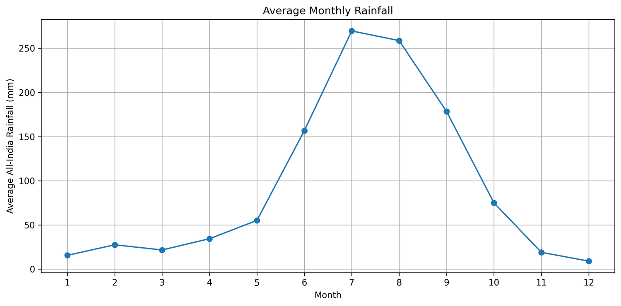
Figure 1. Average monthly All-India rainfall (mm), 2011–2014 (average_monthly_rainfall.png)
What it shows. The x-axis is the month (1 = January to 12 = December); the y-axis is average All-India rainfall in millimetres. Rainfall is low from January to April (roughly 15–35 mm), rises sharply in June (about 155 mm), peaks in July (about 270 mm) and August (about 258 mm), and falls through September (about 178 mm) to its lowest values in November–December (about 19 mm and 9 mm). The shape matches the June–September monsoon season. Values are read approximately from the plot.

3.5 Monthly Air Pollution Analysis
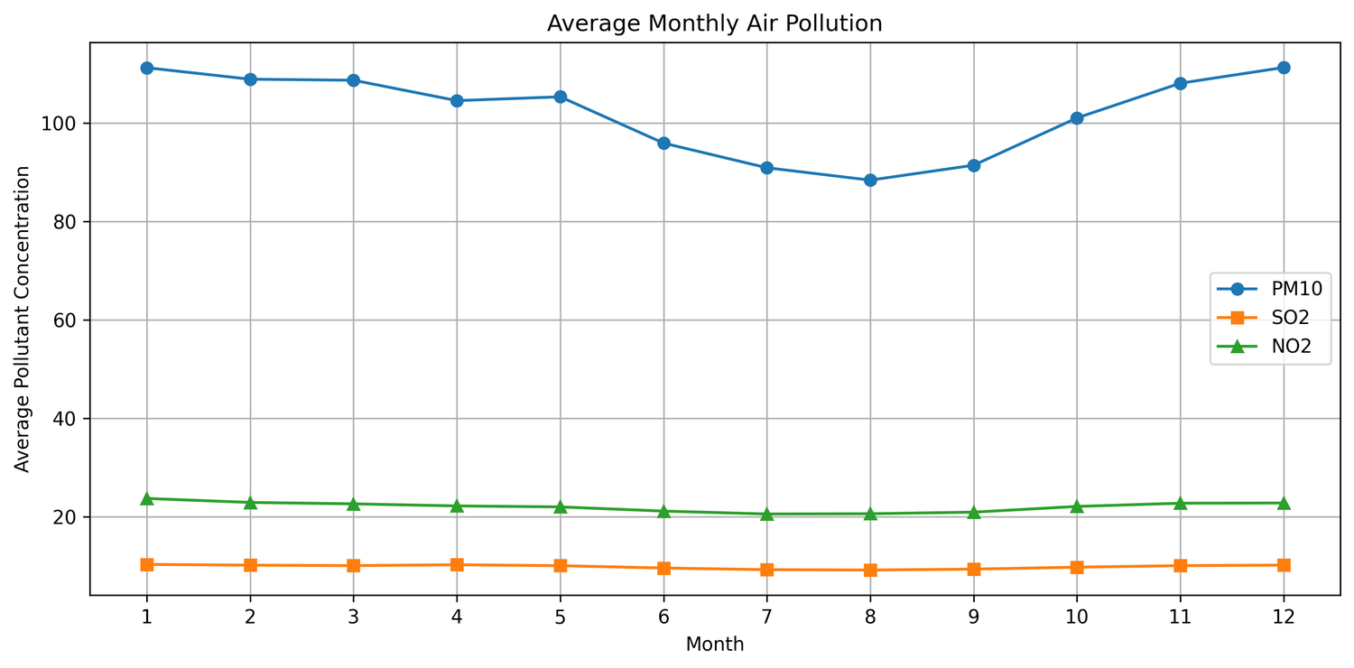
Figure 2. Average monthly PM10, SO2 and NO2 concentrations (average_monthly_air_pollution.png)
What it shows. The x-axis is the month and the y-axis is the average pollutant concentration, with one line per pollutant. PM10 is by far the highest and shows the clearest seasonal pattern: about 111 in January, about 105–109 from February to May, a fall to about 96 in June and about 91 in July, a minimum of about 88 in August, then a rise from September to about 111 again in December. NO₂ stays near 20–24 and SO₂ near 9–10 with only a slight dip in July–August (approximate readings). The graph therefore shows that PM10 is lowest in the same months in which rainfall is highest (Figure 1). This is a visual co-occurrence of two seasonal patterns; it does not by itself show that rainfall lowers PM10.

3.6 Correlation Preview
The correlation analysis in Section 4.2 quantifies the relationships between rainfall, PM10, SO₂ and NO₂. Together, the EDA and the correlation matrix motivate the regression, classification and clustering stages that follow.

4: ANALYSIS ON DATASET
Each analysis below follows the LPU format: (i) Introduction, (ii) General Description, (iii) Specific Requirements, Functions and Formulas, (iv) Analysis Results, and (v) Visualization. Numerical results are shown as highlighted placeholders because the program output was not supplied; they must be copied from your own run. Observations drawn from the supplied graphs are stated as such.

4.1 Data Preprocessing
i. Introduction. Preprocessing converts the raw files into one clean, model-ready table. It is the foundation for all later analyses.
ii. General Description. The rainfall table is in wide format (one column per month), so it is reshaped to long format. The pollution table has many station-level rows, so it is averaged to one row per city, year and month. The two tables are then merged on year and month, cleaned, and enriched with encoded and seasonal features.
iii. Specific Requirements, Functions and Formulas. The steps and the functions used are listed in Table 5. The seasonal categories follow the function assign_season(): Winter (months 12, 1, 2), Pre-Monsoon (3, 4, 5), Monsoon (6, 7, 8, 9) and Post-Monsoon (10, 11). LabelEncoder assigns integer codes in alphabetical order (Monsoon = 0, Post-Monsoon = 1, Pre-Monsoon = 2, Winter = 3).
Table 5. Preprocessing steps implemented in the source code
No. | Step and function | Purpose
1 | Clean column names: str.strip() | Remove stray spaces that break column look-ups.
2 | Convert to numeric: pd.to_numeric(errors="coerce") | Turn text or invalid entries into missing values.
3 | Drop rows with missing year/month: dropna() | Keep only rows with a valid time stamp.
4 | Reshape rainfall: melt() | Wide months (JAN–DEC) → long rows with month and rainfall_mm; month names mapped to 1–12.
5 | Filter 2011–2014: between() | Restrict to the overlapping analysis period.
6 | Aggregate: groupby([year, month, State, City]).agg() | Mean SO2, NO2, PM10 per city-month; also measurement_count (and station_count if available).
7 | Merge: merge(how="left", validate="many_to_one") | Attach the All-India rainfall of the same year and month to every city-month row.
8 | Drop missing essential values: dropna(subset=…) | Require rainfall_mm, PM10_mean, SO2_mean, NO2_mean.
9 | Remove negative values | Keep only rows where rainfall and the three pollutants are ≥ 0.
10 | Encode categories: LabelEncoder() | Create state_code, city_code, season_code.
11 | Create season: assign_season() | Winter, Pre-Monsoon, Monsoon, Post-Monsoon.

iv. Analysis Results. The merged dataset was saved as a CSV file, and the cleaned dataset shape and remaining missing values were printed. Before cleaning (8631,12), After cleaning (8631,16). Missing values were removed, not imputed; although SimpleImputer is imported in the script, it is not used.
v. Visualization. This stage produces no graph; its output is the cleaned table described above.

4.2 Correlation Analysis
i. Introduction. Correlation measures how strongly two numeric variables move together. It is a first check of whether rainfall is related to pollution.
ii. General Description. The code computes the Pearson correlation matrix of rainfall_mm, PM10_mean, SO2_mean and NO2_mean. Values lie between −1 (perfect negative) and +1 (perfect positive); values near 0 indicate no linear relationship.
iii. Specific Requirements, Functions and Formulas. df[correlation_columns].corr() calculates the matrix (Pearson by default). The matrix is drawn with plt.imshow(cmap="coolwarm") and plt.colorbar(). The Pearson formula is given in Chapter 5.
iv. Analysis Results. From the colours in Figure 3, rainfall has a weak negative association with all three pollutants, the most negative being with PM10 (the darkest blue cell, roughly −0.1 to −0.15 judging from the colour bar). PM10 and SO₂ show a weak positive association (about 0.25), and NO₂ is moderately positively associated with both PM10 and SO₂ (about 0.4–0.5). These are visual estimates from the colour scale.
v. Visualization. Figure 3 is the correlation heatmap. Its axes list the four variables; each cell is the correlation between the row and column variable, and the diagonal is 1 (dark red). Blue cells are negative and red cells positive. The map does not print numbers in the cells, and its colour scale runs from the smallest to the largest value in the matrix, so colours should be read together with the colour bar.
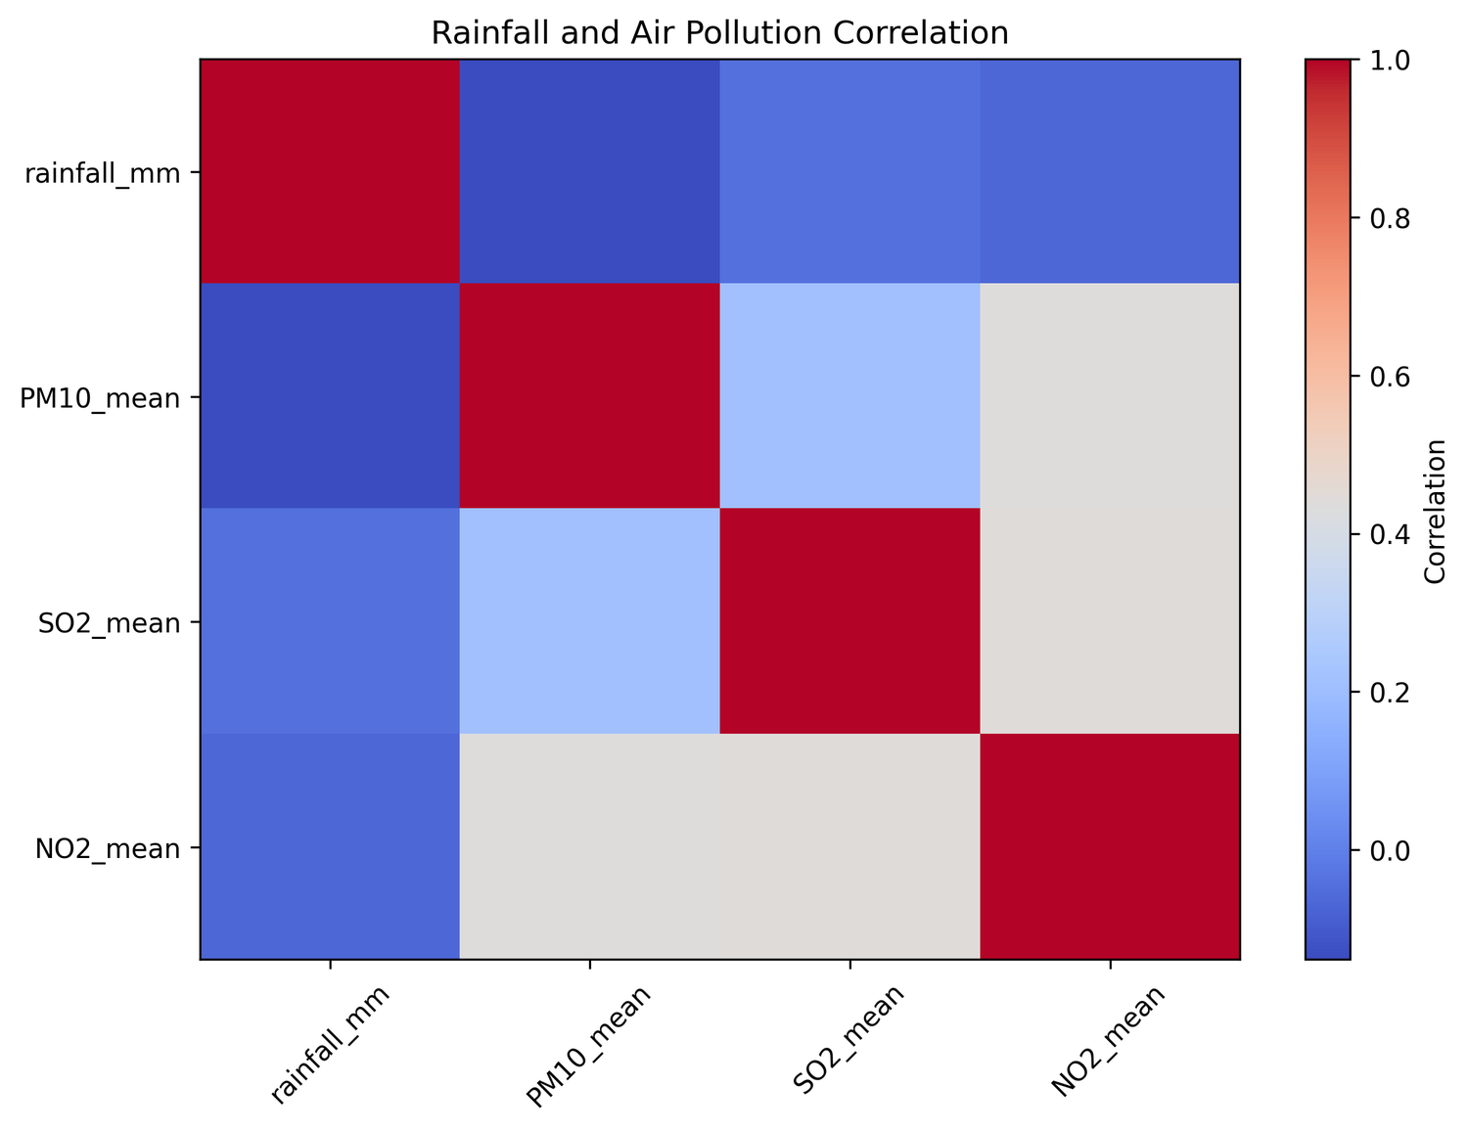
Figure 3. Correlation heatmap of rainfall and pollutants (rainfall_pollution_correlation.png)
A weak negative correlation means that months with more rainfall tend, slightly, to have lower pollutant values. It does not show that rainfall causes the difference, because both variables follow seasonal cycles.

4.3 Simple Linear Regression
i. Introduction. Simple linear regression models the relationship between one predictor and one target with a straight line.
ii. General Description. Rainfall (rainfall_mm) is the independent variable and city-month mean PM10 (PM10_mean) is the dependent variable. The model is PM10 = β₀ + β₁ × rainfall. A negative β₁ would mean lower PM10 at higher rainfall.
iii. Specific Requirements, Functions and Formulas. train_test_split(test_size=0.2, random_state=42) creates a random 80/20 split. LinearRegression().fit() learns β₀ (intercept_) and β₁ (coef_) by least squares; predict() estimates PM10 for the test set. Evaluation uses MAE, MSE, RMSE (np.sqrt(MSE)) and R² from sklearn.metrics.
iv. Analysis Results. Intercept: Intercept: 109.93029845402381. Coefficient: -0.08687471437940716. MAE: 43.65445106876768. MSE: 3214.7328095741277. RMSE:
56.69861382409739. R²: 0.012031789080948818. An R² close to 0 would indicate that rainfall alone explains very little of the variation in PM10.
v. Visualization. Figure 4 plots the test observations as points (x: All-India monthly rainfall in mm; y: city-month average PM10) with the fitted line.
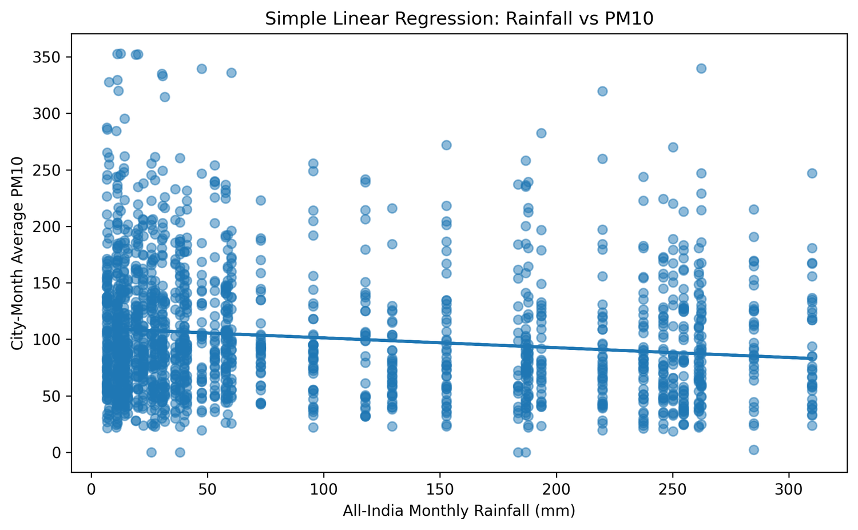
Figure 4. Simple linear regression: rainfall vs PM10 (simple_linear_regression_rainfall_vs_pm10.png)
The fitted line slopes gently downward, from roughly 108 at low rainfall to roughly 83 at about 310 mm, while the points are spread widely from near 0 to about 350 at every rainfall level. The vertical columns of points arise because all cities share the same rainfall value in a given month. The wide scatter around a shallow line suggests that rainfall alone is a weak predictor of PM10; the exact strength is given by R².

4.4 Multiple Linear Regression
i. Introduction. Multiple linear regression uses several predictors at once, so that time and location effects can be included together with rainfall.
ii. General Description. The features are rainfall_mm, month, year, state_code, city_code and season_code, and the target is PM10_mean. Instead of a random split, a time-based split is used: the sorted list of years is divided at 75%, so the test set contains the later year(s) and the training set the earlier ones. With four years (2011–2014) the split position is 3, so the model trains on 2011–2013 and is tested on 2014 (assuming all four years remain after cleaning; confirm from the output). This mimics real forecasting and reduces leakage from future to past.
iii. Specific Requirements, Functions and Formulas. LinearRegression() fits PM10 = β₀ + β₁x₁ + … + β₆x₆. Each coefficient is the expected change in PM10 for a one-unit change in that feature with the others held fixed. Because state_code, city_code and season_code are arbitrary integer labels from LabelEncoder, their coefficients have no natural numeric meaning.
Table 6. Multiple linear regression coefficients (to be filled from output)
Feature | Coefficient
Intercept | 6147.601782635933
rainfall_mm | -0.06473137931993955
month | 0.15955817929751648
year | -3.0125530699625442
state_code | 1.9891267742499268
city_code | -0.10988759818011498
season_code | 2.188764614330768

iv. Analysis Results. MAE: 37.83448641718728; MSE: 2454.083140674929; RMSE: 49.53870346178762; R²: 0.09932775066140831. The code also prints the first ten actual and predicted values. Because the test set is a later year, R² may be lower than for a random split.
v. Visualization. Figure 5 plots actual PM10 (x-axis) against predicted PM10 (y-axis) for the test set; the straight line marks perfect prediction (predicted = actual).
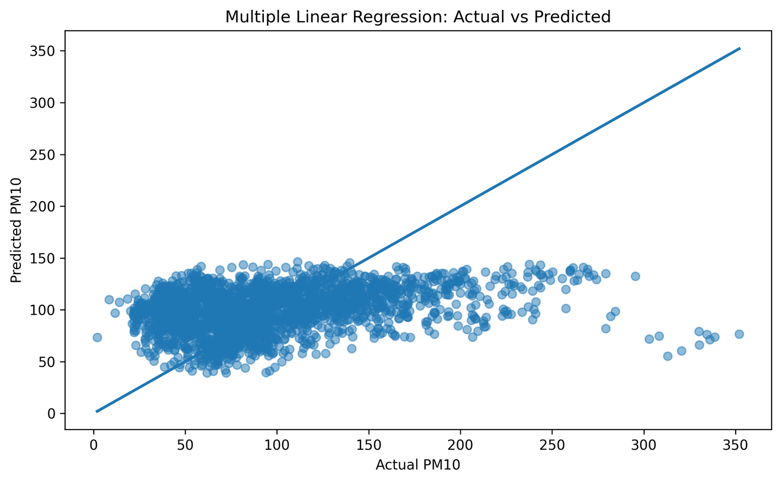
Figure 5. Multiple linear regression: actual vs predicted PM10 (multiple_regression_actual_vs_predicted_pm10.png)
Most predictions lie in a horizontal band between about 40 and 150, although actual values extend beyond 350. Points with high actual PM10 (above about 200) lie far below the line, so the model systematically under-predicts high pollution and compresses the range of values. Predictions near the middle of the range are closer to the line.

4.5 Polynomial Regression
i. Introduction. Polynomial regression allows a curved relationship by adding powers of the predictor.
ii. General Description. A degree-2 polynomial of rainfall is used: PM10 = β₀ + β₁x + β₂x². The same 80/20 split (random_state = 42) as in Section 4.3 is used, so the two models can be compared fairly.
iii. Specific Requirements, Functions and Formulas. PolynomialFeatures(degree=2, include_bias=False) converts x into the columns [x, x²]; the bias column is omitted because LinearRegression already fits an intercept. make_pipeline() chains the transformer and the regressor so that both are fitted and applied together. A 200-point grid from np.linspace() is used to draw a smooth curve.
iv. Analysis Results. MAE: 43.57743327575805; MSE: 3210.152821267349; RMSE: 56.65821053710882; R²: 0.013439334628747468. Compare with Section 4.3 to see whether the curve improves the fit.
v. Visualization. Figure 6 shows test points and the fitted curve (x: rainfall in mm; y: PM10).
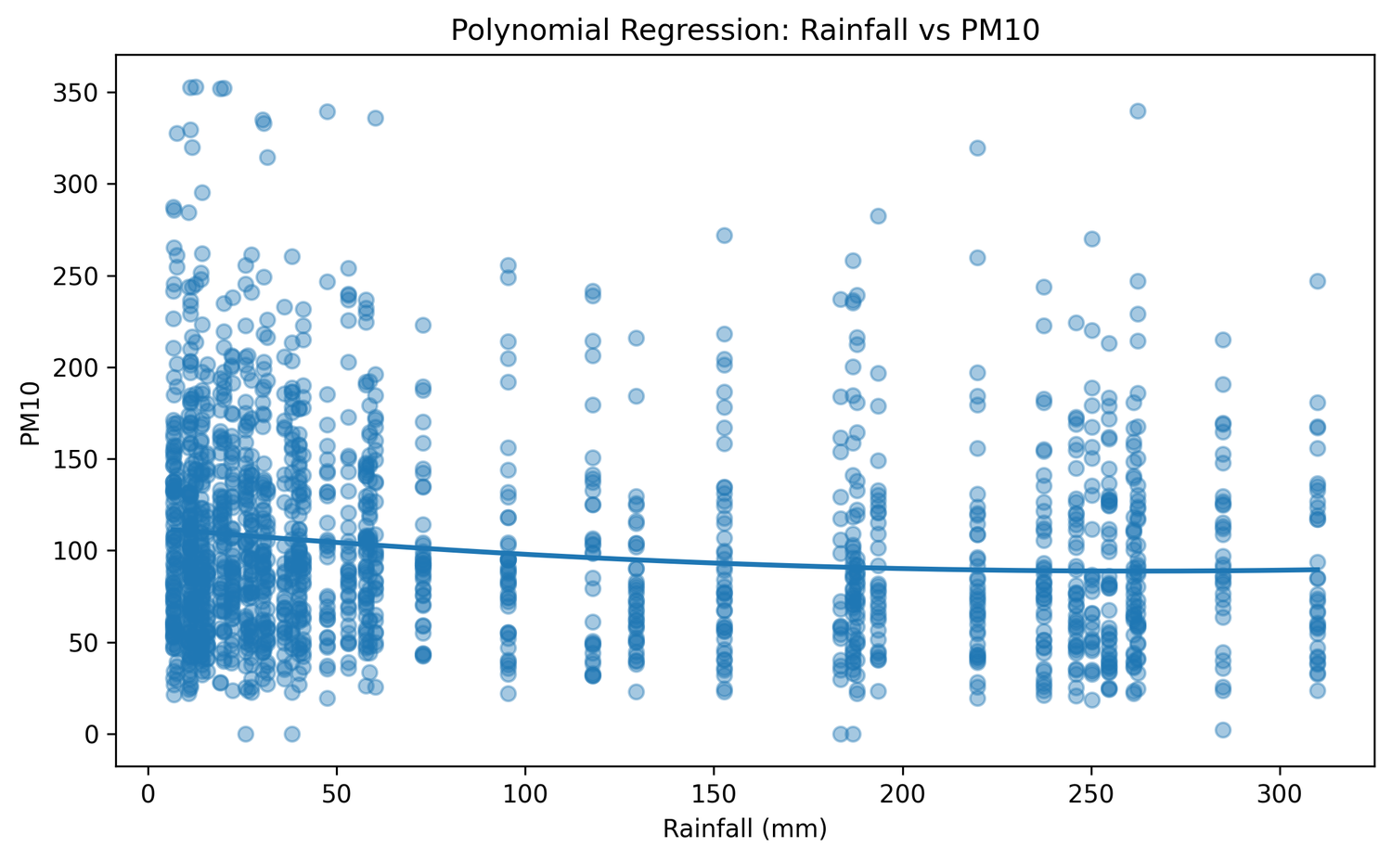
Figure 6. Polynomial (degree 2) regression: rainfall vs PM10 (polynomial_regression_rainfall_vs_pm10.png)
The curve falls from about 110 at low rainfall to about 90 near 200 mm and is nearly flat thereafter, so it is only slightly curved. As in Figure 4, the scatter around the curve is large.

4.6 Logistic Regression
i. Introduction. Logistic regression is a classification method that estimates the probability of belonging to class 1.
ii. General Description. The target is a binary label high_PM10. For each city, the median of PM10_mean over all its months is computed with groupby("City")["PM10_mean"].transform("median"). A record is labelled 1 (High-relative PM10) if its PM10_mean is strictly greater than its own city’s median, and 0 (Normal-relative PM10) otherwise. This is a project-defined relative label and not an official AQI category; it indicates only whether a month is high compared with the same city’s usual level. The features are the six used in Section 4.4.
iii. Specific Requirements, Functions and Formulas. A 80/20 split with stratify=y keeps class proportions equal in training and test sets. StandardScaler rescales each feature to zero mean and unit variance, and LogisticRegression(max_iter=1000) is fitted inside make_pipeline(). The code reports accuracy, precision, recall, F1-score, the confusion matrix, and classification_report (computed only if both classes occur in the test set).
iv. Analysis Results. Accuracy: 0.6352055587724378; Precision: 0.6018018018018018; Recall: 0.780373831775701; F1: 0.6795523906408952; Confusion matrix: [[429 442] [188 668]]. Because the label splits each city around its median, the classes are roughly balanced, so an accuracy near 50% would represent chance-level performance.
v. Visualization. The code produces no graph for this model; results are in the printed metrics and are summarised in Tables 11 and 12.

4.7 K-Nearest Neighbors (KNN)
i. Introduction. KNN classifies a record by looking at the most similar records in the training data.
ii. General Description. For a new city-month, the algorithm finds the 5 nearest training records (k = 5) in feature space and assigns the majority class among them. It stores the training data and does no explicit model fitting.
iii. Specific Requirements, Functions and Formulas. StandardScaler is applied first because KNN depends on distances, and features such as year and city_code would otherwise dominate rainfall. KNeighborsClassifier(n_neighbors=5) uses the default Euclidean distance. The code prints accuracy, precision, recall, F1-score and the confusion matrix.
iv. Analysis Results. Accuracy: 0.6137811233352635; Precision: 0.6110458284371327; Recall: 0.6074766355140186; F1: 0.6092560046865847; Confusion matrix: [[540 331] [336 520]].
v. Visualization. No graph is generated; see Tables 11 and 12.

4.8 Gaussian Naive Bayes
i. Introduction. Gaussian Naive Bayes is a probabilistic classifier based on Bayes’ theorem.
ii. General Description. It estimates, for each class, the mean and variance of every feature, assumes the features are independent given the class and normally distributed, and combines them to compute the probability of each class. The class with the higher probability is predicted.
iii. Specific Requirements, Functions and Formulas. GaussianNB() is used after StandardScaler in a pipeline; scaling is not essential for this algorithm but is harmless. The code reports accuracy, precision, recall, F1, and the confusion matrix. The independence and normality assumptions are only approximate here, since month, year and the encoded codes are discrete.
iv. Analysis Results. Accuracy: 0.6346265199768385; Precision: 0.6018099547511312; Recall: 0.7768691588785047; F1: 0.6782253952065272; Confusion matrix: [[431 440] [191 665]].
v. Visualization. No graph is generated; see Tables 11 and 12.

4.9 Decision Tree Classification
i. Introduction. A decision tree classifies records by asking a sequence of yes/no questions about the features.
ii. General Description. At each node the tree picks the feature and threshold that best separates the classes (measured by Gini impurity) and splits the data. Leaves give the final class.
iii. Specific Requirements, Functions and Formulas. DecisionTreeClassifier(max_depth=5, random_state=42, class_weight="balanced"). max_depth = 5 limits the tree to five levels, controlling over-fitting and keeping it readable. class_weight = "balanced" weights classes inversely to their frequency so a slightly imbalanced label does not bias the tree. plot_tree() draws the tree with feature names and the class names “Normal-relative PM10” and “High-relative PM10”. Reported metrics: accuracy, precision, recall, F1, and confusion matrix.
iv. Analysis Results. Accuracy: 0.6398378691372322; Precision: 0.6020942408376964; Recall: 0.8060747663551402; F1: 0.6893106893106893; Confusion matrix: [[415 456] [166 690]].
v. Visualization. Figure 7 shows the fitted tree. Each box lists the split rule, Gini value, number of samples, class weights (value) and predicted class; blue boxes lean to High-relative PM10 and orange boxes to Normal-relative PM10.
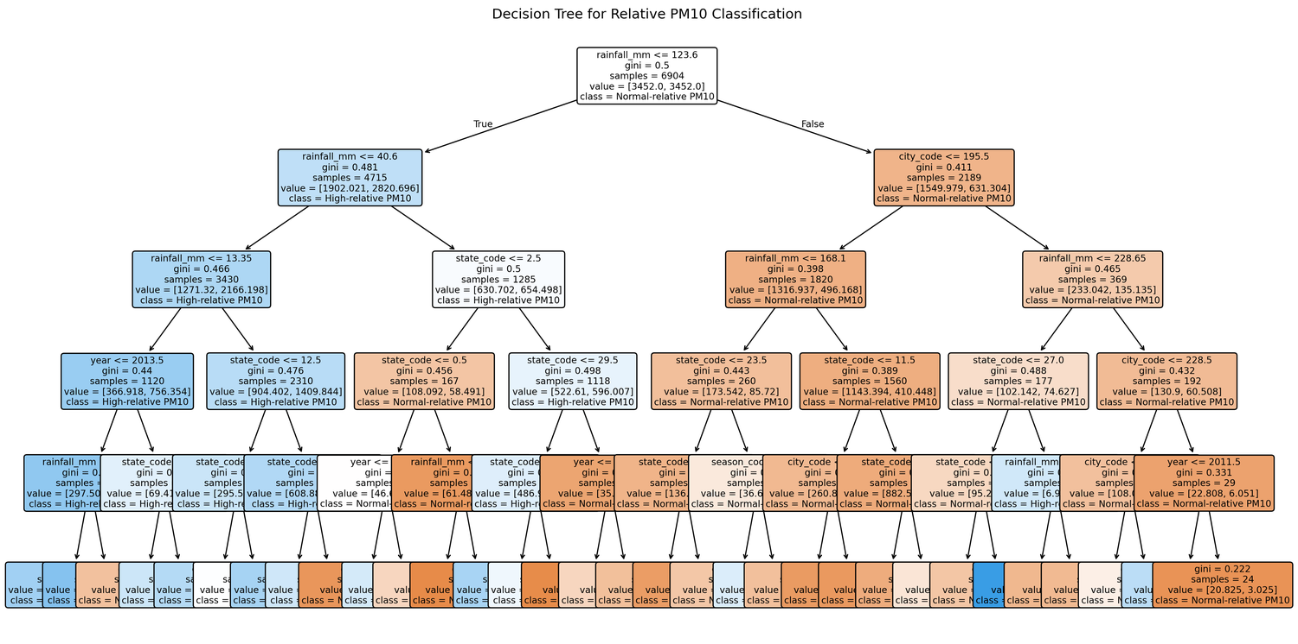
Figure 7. Decision tree for relative PM10 classification (decision_tree_pm10_classification.png)
The root node splits on rainfall_mm ≤ 123.6 using 6,904 training samples with a Gini value of 0.5 (the weighted classes are balanced). The low-rainfall branch (4,715 samples) is split again on rainfall_mm ≤ 40.6 and is predominantly blue (High-relative PM10), whereas the high-rainfall branch (2,189 samples) is split on city_code ≤ 195.5 and is predominantly orange (Normal-relative PM10). Rainfall is therefore the most important first split; deeper levels use state_code, city_code, year and season_code. In the saved image the text in the deepest levels overlaps and is partly unreadable; a larger figure size would make the lower nodes legible.

4.10 Support Vector Machine (SVM)
i. Introduction. An SVM finds a boundary that separates the classes with the largest possible margin.
ii. General Description. With a non-linear RBF (radial basis function) kernel, the SVM can separate classes that are not linearly separable by implicitly mapping records to a higher-dimensional space.
iii. Specific Requirements, Functions and Formulas. SVC(kernel="rbf", probability=True, class_weight="balanced", random_state=42) is used after StandardScaler. Scaling is essential because the RBF kernel depends on distances between records. probability=True enables predict_proba() (scikit-learn estimates probabilities internally with cross-validation). Other parameters (C and gamma) are left at scikit-learn defaults.
iv. Analysis Results. Accuracy: 0.6340474811812391; Precision: 0.6038961038961039; Recall: 0.7605140186915887; F1: 0.6732161323681489; Confusion matrix: [[444 427] [205 651]].
v. Visualization. No graph is generated; see Tables 11 and 12.

4.11 K-Means Clustering
i. Introduction. K-Means is an unsupervised method that groups records into K clusters without using any target label.
ii. General Description. The four features rainfall_mm, PM10_mean, SO2_mean and NO2_mean are used. The algorithm repeatedly assigns each record to the nearest cluster centre and recomputes the centres until they stop changing.
iii. Specific Requirements, Functions and Formulas. StandardScaler puts all four features on the same scale. The elbow method runs KMeans(n_clusters=k, random_state=42, n_init=10) for k = 1 to 10 and records inertia_, the sum of squared distances to the nearest centre. The final model uses three clusters. value_counts() gives the cluster sizes and groupby("cluster").mean() gives the average of each feature per cluster.
iv. Analysis Results. Cluster counts: [4139 2260 2232]. Cluster means: [[36.296956 80.687971 6.497571 15.384029], [232.004248 79.649774 7.865416 18.031564], [58.674731 164.678421 17.918950 38.248745] (Table 13). Cluster numbers 0, 1 and 2 are arbitrary labels.
v. Visualization. Figure 8 is the elbow plot (x: number of clusters K; y: inertia).
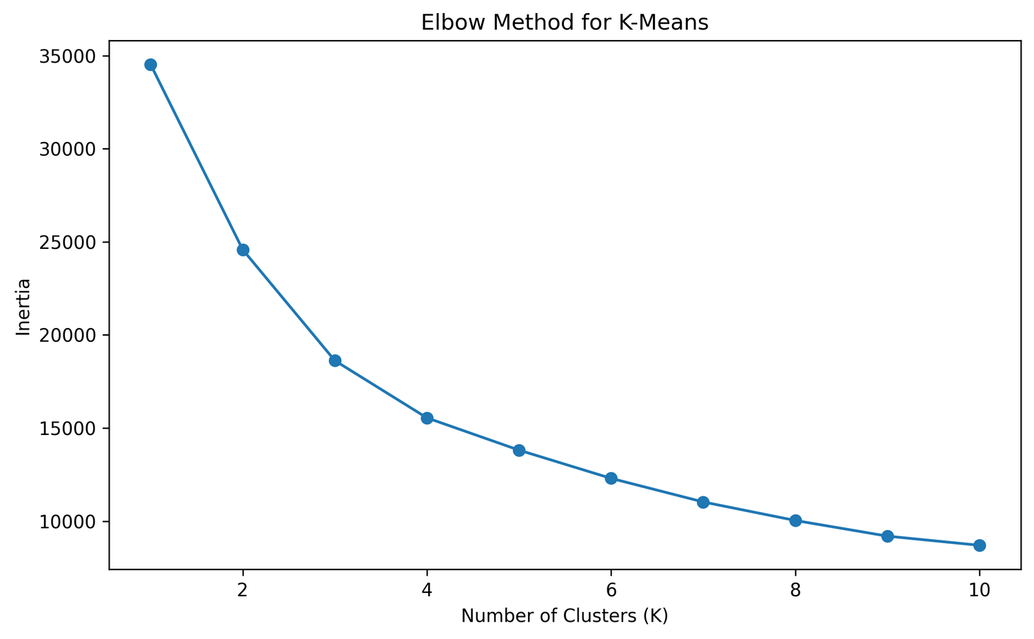
Figure 8. Elbow method for K-Means (kmeans_elbow_method.png)
Inertia falls from about 34,500 at K = 1 to about 24,500 at K = 2, 18,600 at K = 3 and 15,500 at K = 4, and then declines more slowly to about 8,700 at K = 10. There is no sharp elbow; the gain per extra cluster becomes noticeably smaller after K = 3–4, so K = 3 is a reasonable but not unique choice. The code does not compute silhouette scores, so cluster quality is not otherwise measured.

4.12 PCA Visualization
i. Introduction. Principal Component Analysis (PCA) reduces many correlated variables to a few new uncorrelated variables, called principal components, that capture as much variance as possible.
ii. General Description. The four standardised clustering features cannot be drawn directly, so they are projected onto two principal components, PC1 and PC2, and the points are coloured by their K-Means cluster.
iii. Specific Requirements, Functions and Formulas. PCA(n_components=2).fit_transform(X_scaled) returns the two-dimensional coordinates, and explained_variance_ratio_ gives the share of total variance captured by each component (formula in Chapter 5).
iv. Analysis Results. Explained variance ratio of PC1: 0.44005918; PC2: 0.24939819; total of the two: 0.68945737. If the total is well below 100%, some information is lost in the 2-D picture.
v. Visualization. Figure 9 plots PC1 (x-axis) against PC2 (y-axis); colours are K-Means clusters.
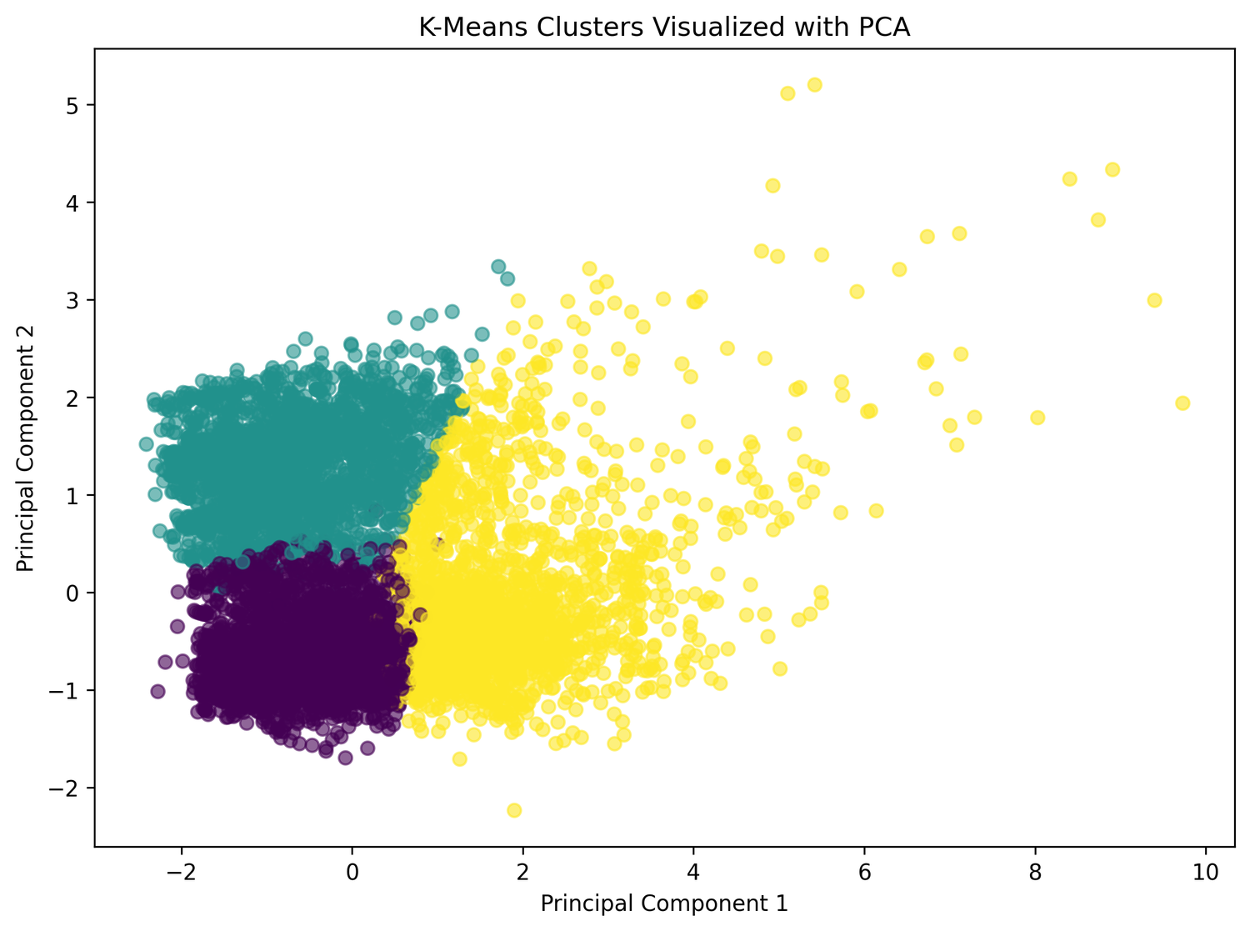
Figure 9. K-Means clusters visualised with PCA (kmeans_clusters_pca.png)
Three regions are visible. One cluster (yellow) occupies positive PC1 values and spreads thinly to PC1 ≈ 10, indicating a group with larger, more extreme feature values. The other two clusters lie at negative-to-small PC1 values and are separated mainly along PC2 (teal above, purple below). The clusters touch and overlap at their edges, because clustering uses four dimensions while the plot shows two. The axes are mixtures of the original features, so they have no direct units.

4.13 Hierarchical Clustering
i. Introduction. Hierarchical (agglomerative) clustering builds clusters from the bottom up by repeatedly merging the two closest groups.
ii. General Description. Every record starts as its own cluster; the closest clusters are merged step by step until the requested three clusters remain.
iii. Specific Requirements, Functions and Formulas. AgglomerativeClustering(n_clusters=3) is applied with scikit-learn defaults (Ward linkage, Euclidean distance). A random sample of min(2000, len(cluster_df)) records is drawn with random_state=42. A maximum of 2,000 is used because hierarchical clustering needs memory and time that grow roughly with the square of the number of records, so using all ~8,600 records would be much slower. The sample is re-scaled with StandardScaler.
iv. Analysis Results. Cluster counts: [733 503 764]; cluster means: [[52.672442 155.137775 15.038845 32.237020], [230.601193 78.692665 8.243970 19.123569], [39.909817 67.842117 6.123332 14.455113] (Table 13). Hierarchical results are from a sample and may differ from the K-Means result on the full data.
v. Visualization. Figure 10 plots All-India rainfall (x-axis) against city-month PM10 (y-axis), coloured by hierarchical cluster.
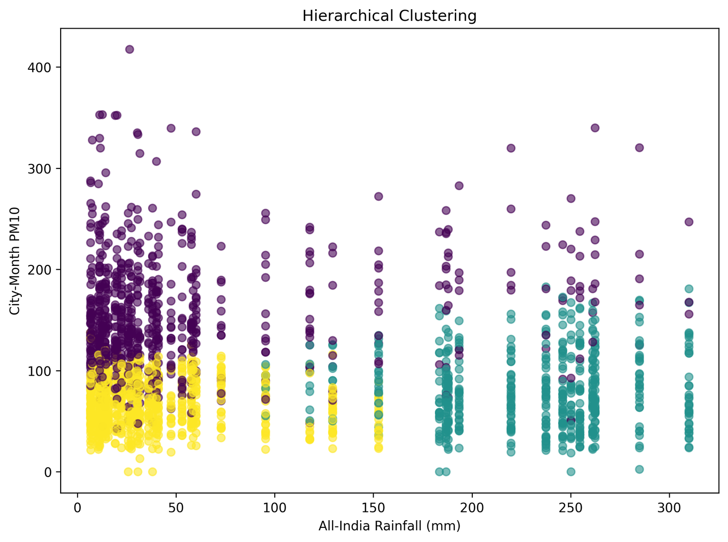
Figure 10. Hierarchical clustering of the sampled city-months (hierarchical_clustering.png)
The teal cluster contains almost all records with rainfall above about 180 mm and spans a wide PM10 range. At low and moderate rainfall the data divide mostly by PM10: the purple cluster holds the high-PM10 records (mostly above about 100, up to about 420) and the yellow cluster holds lower-PM10 records (about 20–115). The groups overlap because SO₂ and NO₂ also influence the clustering but are not shown in this two-dimensional view. No dendrogram is produced by the code.

5: TECHNICAL REQUIREMENTS AND FORMULAS

5.1 Mathematical Formulas
Table 7 lists the formulas behind the metrics and models used in the code. Table 8 lists additional formulas given as theoretical background; they describe how the scikit-learn algorithms work internally and are not coded explicitly in the project.
Table 7. Formulas for the models and metrics computed in the project
Concept | Formula | Symbols / where used
Mean | x̄ = (1/n) Σ xᵢ | n = number of values; groupby().mean(), cluster means
Pearson correlation | r = Σ(xᵢ − x̄)(yᵢ − ȳ) / √[Σ(xᵢ − x̄)² · Σ(yᵢ − ȳ)²] | corr() in Section 4.2
Simple linear regression | ŷ = β₀ + β₁x | x = rainfall, ŷ = predicted PM10 (4.3)
Multiple linear regression | ŷ = β₀ + β₁x₁ + β₂x₂ + … + β₆x₆ | Six features (4.4)
Polynomial regression (degree 2) | ŷ = β₀ + β₁x + β₂x² | PolynomialFeatures (4.5)
MAE | (1/n) Σ |yᵢ − ŷᵢ| | Average absolute error
MSE | (1/n) Σ (yᵢ − ŷᵢ)² | Average squared error
RMSE | √MSE | Error in the units of PM10
R² score | 1 − Σ(yᵢ − ŷᵢ)² / Σ(yᵢ − ȳ)² | 1 = perfect; 0 = no better than the mean
Accuracy | (TP + TN) / (TP + TN + FP + FN) | Correct predictions share
Precision | TP / (TP + FP) | Of predicted High, share truly High
Recall | TP / (TP + FN) | Of true High, share found
F1-score | 2 · Precision · Recall / (Precision + Recall) | Harmonic mean
K-Means objective | J = Σₖ Σ (x ∈ Cₖ) ||x − μₖ||² | Cₖ = cluster k, μₖ = centre; inertia_
PCA explained variance | EVRₖ = λₖ / Σⱼ λⱼ | λ = eigenvalue of the covariance matrix

Table 8. Additional theoretical background formulas (not coded explicitly)
Concept | Formula | Used in
Logistic (sigmoid) function | p = 1 / (1 + e^−(β₀ + Σβⱼxⱼ)) | Logistic regression (4.6)
Log loss | −(1/n) Σ [y log p + (1 − y) log(1 − p)] | Logistic, NB, SVM
Euclidean distance | d(a, b) = √Σ (aⱼ − bⱼ)² | KNN, K-Means, Ward
Bayes’ theorem | P(C|x) ∝ P(C) ∏ P(xⱼ|C) | Gaussian Naive Bayes (4.8)
Gini impurity | G = 1 − Σ pᵢ² | Decision tree (4.9)
RBF kernel | K(x, x′) = exp(−γ ||x − x′||²) | SVM (4.10)
Standardisation | z = (x − μ) / σ | StandardScaler

5.2 Python Libraries and Functions Used
Table 9 lists only the libraries and functions that appear in the source code and describes their role in this project. The script also imports SimpleImputer and cross_val_score, but they are not called, so no imputation or cross-validation was performed.
Table 9. Libraries and functions used in the implementation
Library / function | Role in the project
pandas | Tabular data handling: loading, cleaning, grouping, merging, saving CSV.
NumPy | np.sqrt (RMSE), np.linspace (smooth curve grid), np.unique (checks both classes exist).
Matplotlib | plt.plot, scatter, imshow, colorbar, savefig for all ten graphs.
scikit-learn | Preprocessing, models, pipelines, metrics, clustering and PCA.
read_excel() | Reads the two .xlsx datasets into DataFrames.
melt() | Converts rainfall from wide (month columns) to long format.
groupby() | Aggregates city-month means, monthly summaries, city medians, cluster means.
merge() | Left-joins rainfall to pollution on year and month (many-to-one).
dropna() | Removes rows with missing year, month or essential variables.
LabelEncoder() | Encodes State, City and season as integers.
StandardScaler() | Standardises features for logistic regression, KNN, NB, SVM and clustering.
train_test_split() | Random (stratified for classification) 80/20 splits.
LinearRegression() | Simple, multiple and (within a pipeline) polynomial regression.
PolynomialFeatures() | Creates x and x² terms (degree 2).
LogisticRegression() | Binary classifier for the relative PM10 label.
KNeighborsClassifier() | KNN classifier with 5 neighbours.
GaussianNB() | Gaussian Naive Bayes classifier.
DecisionTreeClassifier() | Tree with max_depth = 5 and balanced class weights.
SVC() | RBF-kernel support vector classifier with probability output.
KMeans() | Elbow analysis (k = 1–10) and final 3-cluster model.
AgglomerativeClustering() | Hierarchical clustering with three clusters.
PCA() | Two-component projection for the cluster plot.
save_graph() | User-defined function that saves each figure as a 300-dpi PNG, displays it, and closes it.

6: RESULTS AND DISCUSSION

6.1 How the Results Are Presented
The numerical results of the models are produced when the Python script is executed. They were not supplied with the code, so the cells below contain highlighted placeholders to be filled from your console output. No value has been estimated. Observations about the graphs, however, are based on the images you supplied.

6.2 Regression Model Comparison
Table 10. Comparison of regression models (target: PM10_mean)
Model | Features | Split | MAE | MSE | RMSE | R²
Simple linear | rainfall_mm | Random 80/20 | 43.65 | 3214.73 | 56.69 | 0.012
Multiple linear | 6 features | Time-based | 37.83 | 2454.08 | 49.53 | 0.099
Polynomial (deg. 2) | rainfall_mm, rainfall² | Random 80/20 | 43.57 | 3210.15 | 56.65 | 0.013

The multiple regression uses a different (time-based) test set from the other two, so its errors are not strictly comparable with them. Lower MAE, MSE and RMSE and higher R² indicate a better fit.

6.3 Classification Model Comparison
Table 11. Comparison of classification models (relative high-PM10 label)
Model | Accuracy | Precision | Recall | F1 | Scaled
Logistic regression | 0.635 | 0.601 | 0.780 | 0.679 | Yes
KNN (k = 5) | 0.613 | 0.611 | 0.607 | 0.609 | Yes
Gaussian NB | 0.634 | 0.601 | 0.776 | 0.678 | Yes
Decision tree | 0.639 | 0.602 | 0.806 | 0.689 | No
SVM (RBF) | 0.634 | 0.603 | 0.760 | 0.673 | Yes

Table 12. Confusion matrix counts on the test set (Class 1 = High-relative PM10)
Model | TN | FP | FN | TP
Logistic regression | 429 | 442 | 188 | 668
KNN | 540 | 331 | 336 | 520
Gaussian NB | 431 | 440 | 191 | 665
Decision tree | 415 | 456 | 166 | 690
SVM (RBF) | 444 | 427 | 205 | 651

All five classifiers use the same stratified test split, so their scores are directly comparable. Because the label is built from each city’s median, the two classes are roughly equal in size; accuracy near 50% would therefore mean performance no better than chance. The label is relative and is not an AQI category.

6.4 Clustering Results
Table 13. Cluster counts and mean feature values (to be filled from output)
Method / cluster | Count | Rainfall (mm) | PM10 | SO2 | NO2
K-Means 0 | 4139 | 36.296 | 80.687 | 6.497 | 15.384
K-Means 1 | 2260 | 232.004 | 79.649 | 7.865 | 18.031
K-Means 2 | 2232 | 58.674 | 164.678 | 17.918 | 38.248
Hierarchical 0 | 733 | 52.672 | 155.167 | 15.038 | 32.237
Hierarchical 1 | 503 | 230.601 | 78.692 | 8.243 | 19.123
Hierarchical 2 | 764 | 39.909 | 67.842 | 6.123 | 14.455

PCA explained variance (PC1, PC2): [0.44005918 0.24939819]. Hierarchical counts sum to the sample size (at most 2,000); K-Means counts sum to the full cleaned dataset.

6.5 Discussion of Observations Supported by the Graphs
- Seasonality. Rainfall peaks in July–August (Figure 1) and average PM10 is lowest in August and highest in December–January (Figure 2). The two seasonal curves move in opposite directions.
- Correlation. The heatmap (Figure 3) shows weak negative colours between rainfall and the pollutants, strongest for PM10, and positive associations among the pollutants.
- Regression. The fitted lines (Figures 4 and 6) slope only gently downward with large scatter; the multiple regression predictions (Figure 5) are confined to a narrow band and under-predict high PM10.
- Classification. The decision tree (Figure 7) chooses rainfall_mm for its first two splits and associates low rainfall with the High-relative class.
- Clustering. The elbow curve (Figure 8) gives no sharp elbow but supports K = 3 as a reasonable choice. The hierarchical clusters (Figure 10) separate high-rainfall records from low-rainfall records and, among the latter, high PM10 from lower PM10.
Conclusions about accuracy, R² and cluster sizes must wait until the placeholders above are completed from your output.

6.6 How to Interpret the Results
- An R² near 0 means the model explains almost none of the variation; a negative R² means it predicts worse than simply using the mean.
- MAE and RMSE are in the units of PM10; RMSE penalises large errors more than MAE, so RMSE much larger than MAE signals some very poor predictions.
- Precision and recall describe High-relative PM10 detection: low recall means many high-PM10 months were missed; low precision means many false alarms.

6.7 What the Analysis Can and Cannot Establish
The analysis can describe how rainfall and PM10, SO₂ and NO₂ vary together in the four-year data and how well the chosen features predict PM10 for this dataset. It cannot show that rainfall causes a change in pollution. Rainfall and pollution both follow seasonal cycles, and other seasonal factors (for example temperature, wind, and emission patterns) are not in the data, so the association may be driven by them. Further limits are: one All-India rainfall value is used for every city; only four years are available; the multiple-regression test set is a single year; encoded city, state and season codes are treated as numbers; and no cross-validation or hyperparameter tuning was performed.

7: CONCLUSION

7.1 Summary of the Project
The project studied the relationship between All-India monthly rainfall and city-level PM10, SO₂ and NO₂ for 2011–2014. Two Excel datasets were cleaned, reshaped, aggregated, and merged into a city-month dataset, which was then analysed using EDA, correlation analysis, three regression models, five classification models, K-Means with PCA, and hierarchical clustering.

7.2 Main Analytical Work Completed
- Data preprocessing, including melt(), aggregation, merging, encoding and seasonal feature creation.
- Regression (simple, multiple with a time-based split, polynomial) and classification of a project-defined relative PM10 label.
- Unsupervised analysis with K-Means (elbow method, three clusters), PCA visualisation, and agglomerative clustering.

7.3 Findings Supported by the Results
From the supplied graphs: (1) rainfall is concentrated in June–September and peaks in July–August; (2) average PM10 is lowest in the monsoon months, around August, and highest in winter months; (3) the correlation between rainfall and PM10 appears weak and negative; (4) simple and polynomial fits slope gently downward with large scatter, and the multiple regression under-predicts high PM10; (5) the decision tree splits first on rainfall; and (6) three clusters are a reasonable choice according to the elbow curve.
The Multiple Linear Regression model achieved the best regression performance, with an MAE of 37.83, MSE of 2454.08, RMSE of 49.54 and R² of 0.0993. Among the five classification models, the Decision Tree achieved the highest accuracy of 63.98% and F1-score of 0.6893. It also achieved the highest recall of 0.8061. These results indicate that the models provide moderate classification performance, while the regression models have limited predictive accuracy.

7.4 Learning Outcomes
- Practical use of pandas for merging data from two sources.
- Understanding of regression, classification and clustering workflows and their evaluation metrics.
- Awareness of data leakage, class balance, feature scaling, and the difference between correlation and causation.

7.5 Limitations
The limitations are listed in Sections 2.6 and 6.7: national rainfall instead of city rainfall, a short time span, a single-year test set for the time-based split, arbitrary integer encoding of categories, a relative (non-AQI) label, and no cross-validation or tuning.

8: FUTURE SCOPE
The following items are proposed future work and are not part of the implemented project.
Table 14. Proposed future improvements
Proposed improvement | Description
More recent data | Extend beyond 2014/2015 using newer rainfall and air-quality records to test whether the findings hold.
Weather variables | Add humidity, temperature and wind speed, which also affect pollutant levels.
City-level rainfall | Use rainfall for each city or region instead of one All-India value.
AQI-based analysis | Convert pollutant values to official AQI categories and classify them.
Time-series forecasting | Apply ARIMA, Prophet or LSTM models to forecast monthly PM10.
Advanced models | Try Random Forest, Gradient Boosting or XGBoost.
Better encoding | Use one-hot or target encoding for city and state instead of integer labels.
Model optimisation | Use cross-validation and hyperparameter search (e.g. GridSearchCV).
Geographic visualisation | Plot city-wise results on maps.
Real-time monitoring | Connect to live air-quality feeds and build a dashboard.

9: REFERENCES
[1] Python Software Foundation. Python 3 Documentation. https://docs.python.org/3/
[2] McKinney, W. (2010). Data structures for statistical computing in Python. Proceedings of the 9th Python in Science Conference, 51–56. pandas documentation: https://pandas.pydata.org/docs/
[3] Harris, C. R., et al. (2020). Array programming with NumPy. Nature, 585, 357–362. NumPy documentation: https://numpy.org/doc/stable/
[4] Hunter, J. D. (2007). Matplotlib: A 2D graphics environment. Computing in Science & Engineering, 9(3), 90–95. Documentation: https://matplotlib.org/stable/
[5] Pedregosa, F., et al. (2011). Scikit-learn: Machine learning in Python. Journal of Machine Learning Research, 12, 2825–2830. Documentation: https://scikit-learn.org/stable/
[6] Central Pollution Control Board (CPCB), India. About NAMP (National Air Quality Monitoring Programme). https://www.cpcb.nic.in/about-namp/
[7] Open Government Data Platform India. All India Area Weighted Monthly, Seasonal and Annual Rainfall (in mm). https://www.data.gov.in/catalog/all-india-area-weighted-monthly-seasonal-and-annual-rainfall-mm
[8] India Meteorological Department (2015). All-India Area Weighted Monthly, Seasonal and Annual Rainfall: 1901–2014 (catalogue entry, People’s Archive of Rural India). https://ruralindiaonline.org/en/library/resource/all-india-area-weighted-monthly-seasonal-and-annual-rainfall-1901-2014/
[9] Hastie, T., Tibshirani, R., & Friedman, J. (2009). The Elements of Statistical Learning (2nd ed.). Springer.
[10] James, G., Witten, D., Hastie, T., & Tibshirani, R. (2021). An Introduction to Statistical Learning (2nd ed.). Springer.
[11] Pearson, K. (1901). On lines and planes of closest fit to systems of points in space. Philosophical Magazine, 2(11), 559–572.
[12] Lloyd, S. P. (1982). Least squares quantization in PCM. IEEE Transactions on Information Theory, 28(2), 129–137.
[13] Cover, T., & Hart, P. (1967). Nearest neighbor pattern classification. IEEE Transactions on Information Theory, 13(1), 21–27.
[14] Cortes, C., & Vapnik, V. (1995). Support-vector networks. Machine Learning, 20(3), 273–297.
[15] Breiman, L., Friedman, J., Olshen, R., & Stone, C. (1984). Classification and Regression Trees. Wadsworth.
[16] Ward, J. H. (1963). Hierarchical grouping to optimize an objective function. Journal of the American Statistical Association, 58(301), 236–244.

